

Faculty of Engineering and Technology
Electrical and Computer Engineering Department Computer Networks Laboratory ENCS4130

Exp#8 – Switching and VLANs (Router on Static and Switch Router Interface)

Prepared by: Aya Dahbour 1201738

Instructor: Sameh Awad

Teacher assistant: Eng. Ahed Mafarjeh

Section: 8

January – 2024

Abstract
In this practical experiment, we delve into the intricacies of VLANs and multi-layer switches, focusing on virtually connecting routers and host devices. The exercise emphasizes configuring switches into virtual segments using IOS command lines and partitioning a router’s interface into sub-interfaces. Utilizing Cisco Packet Tracer software, the experiment provides a simulated network environment equipped with routers, switches, multi-layered switches, various cabling, and host devices like PCs and laptops, offering a hands-on experience in advanced network management.

Contents
Abstract I
Acronyms and Abbreviations III
List of Figures IV
List of Tables V
1. Theory 6
1.1. How do Switches Work 6
1.2. IEEE 802.1Q VLAN 6
1.3. VLAN Numbering 7
1.4. Trunks and Access Ports 7
1.5 Sub Interface on Routers 8
1.6 Third Layer Switch 9
1.7 Configurating Third Layer Switch 9
2. Procedure and Discussion 10
• Building the topology 10
2.1. Creating All VLANs 11
2.2. Configuring Routers & PCs 11
2.3. Configuring Switches 13
2.4. Adding the Third Layer switch to The Topology 14
2.5. Multilayer Switch Configurations 15
2.5. Multilayer Switch Configurations 16
3. Results 17
3.1. Results for the Router on Stick Part 17
3.2. Results for The Switch Virtual Interface Part 18
4. To Do 19
4.1. Building the topology 19
4.2 IPs configuration: 20
4.3 Creating VLANs: 21
4.4 Configuring EIGRP Routing: 22
4.5 Results: 22
Conclusion 23
References 24

Acronyms and Abbreviations
VLAN: Virtual Local Area Network
OSPF: Open Shortest Path First
WAN: Wide Area Networks

| P a g e

List of Figures
Figure ‎1-1: Network switch [3] 6
Figure ‎1-2: Virtual local area network [5] 7
Figure ‎1-6: Third layer switch topology 9
Figure ‎2-1: Router on stick topology 10
Figure ‎2-2: Switch virtual interface topology 10
Figure ‎2-4: IP configuration for PC0 13
Figure ‎2-5: IP configuration for a multi-layer switch PC 16
Figure ‎3-1: Pinging PCs using the command prompt 17
Figure ‎3-1-1: Pinging results 17
Figure ‎3-2: Pinging PCs that are connected to the multi-layer switch 18
Figure ‎3-2-1: Pinging results after connecting the multi-layer switch 18
Figure ‎4-1: ToDO Topology 19
Figure ‎4-1-1: IP addresses for PC 20
Figure ‎4-1-2: IP addresses for Laptop 20
Figure ‎4-1-3: IP addresses for Server 20
Figure ‎4-5: ToDo Results 22

List of Tables

Table 1-2: MAC Address Distribution 6
Table 2-2: ROS Networks IPs 11
Table 2-3: Switches Ports 13
Table 2-4: SVI Networks IPs 14

Theory
Switches are simply devices there are used to connect other devices on a computer network using packet switching, and for this experiment these switches are being used to configure the VLAN (virtual local area network). [2]

1.1. How do Switches Work
Switches work by extracting the MAC address of the sending device and links it to the port
that the device is sending on, where the switch ends up building a table of MAC-ports in order
for it deliver packets between its devices, a switch can be seen in figure 1-1 below.
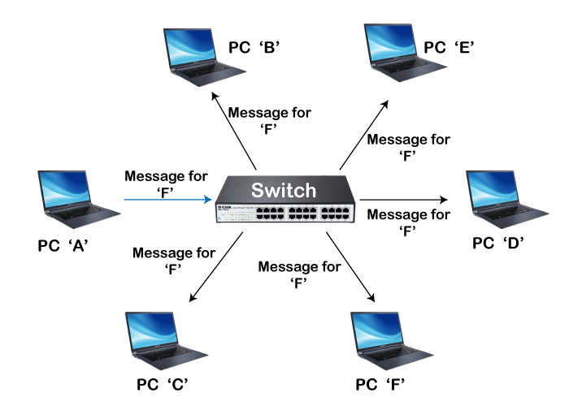
Figure 1-1: Network switch [3]

1.2. IEEE 802.1Q VLAN
VLAN which is an observation of the term virtual local area network, which is a logical network that groups together a subset of devices where they all share the same physical LAN, isolating the traffic for each group, and it is in the link layer. _{[4]}
By the term virtual the computers are configured through software rather than physical hardware, so any physical changes of the computer won’t affect its connection on the VLAN, so it’s like these computers are connected on the same wire although they are on different segments, where IEEE 802.1Q is the used protocol for carrying VLAN traffic on the ethernet which makes VLAN a good option for traffic segregation
VLAN has a 4-byte tag that distinguishes its frame from the ordinary ethernet frames where the tag is placed between the Ether Type and the source MAC as shown in table 1-1.
Table 1-2: MAC Address Distribution
0 | 1 | 2 | 3 | 4 | 5 | 6 | 7 | 8 | 9 | 10 | 11 | 12 | 13 | 14 | 15 | 16 | 17 | 18….
 | Destination Address |  |  |  |  |  |  | Source Address |  |  |  | VLAN Tag |  |  |  | Ether Type |  | Payload
 |  |  |  |  |  |  |  |  |  |  |  | 0x8100 |  | TCI
As shown in table 1-1 the MAC address goes as follows: the first 6-bits are for the destination address, then 6 other bits for the source address ,then 4-bits for the VLAN tag which consists of the TPID (tag protocol ID) which is defined to be 0x8100 as shown in the table and the tag also consists of the TCI (tag control information) of which is a 2-byte 12-bits of them correspond to the VID (VLAN ID) and the other 4 for the meta data that is used for the quality of the service management, after the VLAN tag, after the VLAN tag in the MAC address comes 2-bits for the ether-type and the rest of the bits are for the payload.
Figure 1-2 below shows an example of the use of VLAN.
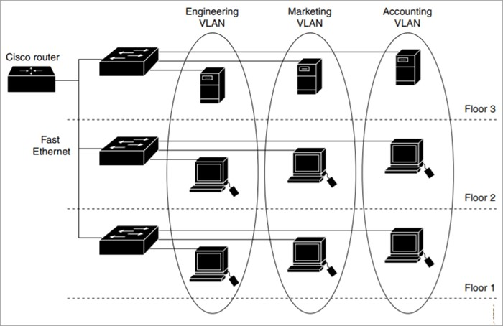
Figure 1-2: Virtual local area network [5]

1.3. VLAN Numbering

As said before the VLAN identifier consists of 12-bits in the range 1-4094 (values 0 and 4095 are reserved and should not be used), in order to create a VLAN on a switch using the following command.
Switch(config)# VLAN <VLAN-NUMBER>
And to check the VLAN on the switch the following command can be used.
Switch(config)# SHOW VLAN

1.4. Trunks and Access Ports
In VLAN switches used switchports can be either access port or a trunk.

1.4.1. Trunk Switch Port
A trunk is used in order to manage the VLAN traffic as it uses the mapping concept to mark each packet so it would be known for the switch where the traffic should be forwarded.

Using trunk port, the VLAN is handled by the attached machine (which sees 802.1Q-tagged Ethernet frames), and to configure a trunk cable on a switch the following command is used.
Switch(config-if)# switchport mode trunk

So, trunks are configured on the ports of the switch that are connected to other switches or to routers, and by configuring one end as a trunk the other end will automatically become a trunk too.

1.4.2. Access Switch Port
Access ports are used so the switch connects the PC that needs to be connected with the VLAN, and by using the access port the VLAN is handled by the switch (so the machine sees untagged Ethernet frames).
The following command is used in order to assign an interface to an existing VLAN (the VLAN should be configured in the switch).
Switch(config-if)# switchport access VLAN <VLAN-NUMBER>

Also, multiple interfaces can be assigned into one VLAN using the command below in order to access these interfaces.
Switch(config)#interface range <TYPE> <SLOT>/<START-PORT> - <ENDPORT>

1.5 Sub Interface on Routers

A sub interface is part of the actual interface on the router that can take its own IP address and it also takes part of its bandwidth, and it passes a special kind of traffic.
In order to tag the traffic in the sub interface, each sub interface has its own encapsulation number which is the VLAN ID that is initialized on the switch.
In order to define and access a sub interface the following command is used.
Router(config)# interface <TYPE> <SLOT>/<PORT>.<SUB-INTERFACE_NUMBER>

As shown above the command takes the normal interface access command then with a dot to the sub interface number.
In order to add an IP address after accessing the sub interface, first the encapsulation should be configured in the sub interface using the command below.
Router(config-subif)#encapsulation dot1Q <VLAN-ID>

Then the IP address command can be used
Router(config-subif)#ip address <IP-ADDRESS> <SUBNET-MASK>

1.6 Third Layer Switch
A switch with three layers has some features that won’t be found in an ordinary switch like routing in parallel with switching, where it acts as both a switch and a router where it connects devices in the same subnet or LAN, and it also supports routing protocols and inspect incoming packets too. In a three layer switch a client’s computer requires a default gateway for layer 3 connectivity to remote subnet. _{[6]}
This type of switches comes with 24 ethernet ports yet no WAN interface, its switching algorithm is simple. The switch has some benefits as improving fault isolation, reducing broadcast traffic volumes, and simplifying security management. And the switch also has its own disadvantages like its cost, limited applications, lack of WAN functionality, and the lack of flexibility too, the figure below shows a topology that is centralized by a third layer switch.
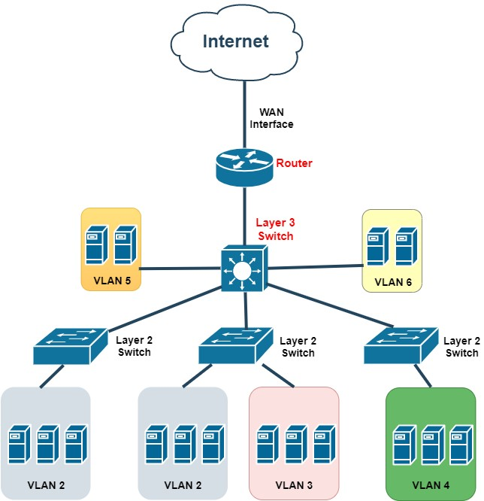
Figure 1-6: Third layer switch topology

1.7 Configurating Third Layer Switch
In the configuration of the third layer switch, first in order to make the switch work as a router, the following commands are entered after entering the needed interface, as it gives it an IP address and a subnet mask.
Switch(config-if)#no switchport
Switch(config-if)# ip address <IP-ADDRESS> <SUBNET-MASK>
For this type of switches the default configurations wont give it the ability to route packets, so it needs to be enabled using the command below.
Switch(config)# ip routing
The new VLANs should be created as before, then the virtual interface should be configured on the switch in order to act as a default gateway for the new VLANs, and that will be done using the following commands.
Switch(config)#interface vlan <VLAN-NUMBER>
Switch(config-if)# ip address <IP-ADDRESS> <SUBNET-MASK>

2. Procedure and Discussion

Building the topology
In order to begin this Cisco packet tracer experiment, the router on stick portion will first be completed using the topology shown in figure 2-1, along with the necessary VLANs, protocols, and setups for the switches, routers, and PCs.
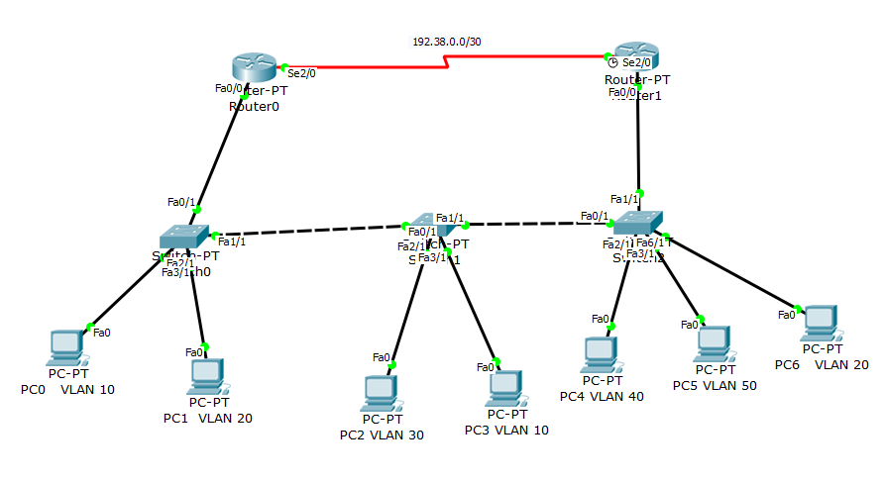
Figure 2-1: Router on stick topology
After this section is completed and tested, the multilayered switch will be set up in order to complete the second part, which is the switch virtual interface part, as shown in figure 2-2. 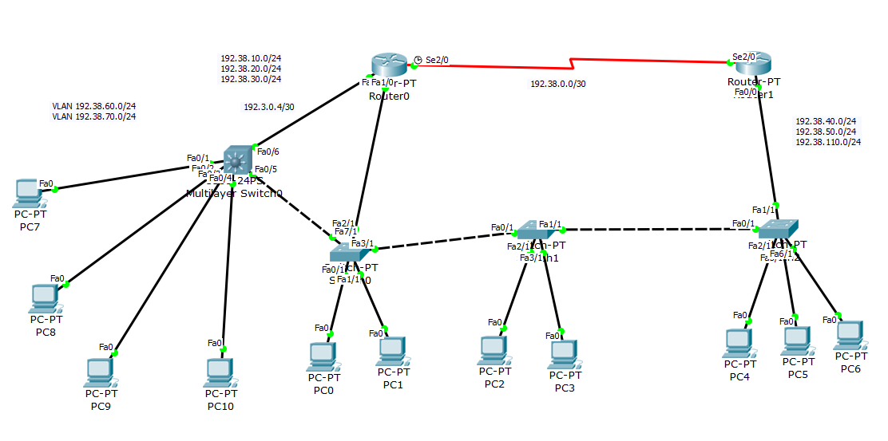
Figure 2-2: Switch virtual interface topology

2.1. Creating All VLANs

All VLANs must be on all switches, so each switch of the three switches should have all the existing five VLANs, in order to add a VLAN on a switch the switch should be enabled then configured then, in order to add a VLAN the command below is used.

Switch(config)# VLAN <VLAN-NUMBER>

Switch(config)# exit

For example, adding VLAN 10, then VLAN 20 on one switch.

Switch(config)# VLAN 10 Switch(config)# exit

Switch(config)# VLAN 20

Switch(config)# exit

2.2. Configuring Routers & PCs
The hosts IP addresses for all their networks are all displayed in table 2-2 below.
Table 2-2: ROS Networks IPs
Area | Network | Device | Interface | IP Address | Subnet Mask | Wildcard Mask | VLAN ID
Area 0 | 192.38.0.0/30 | Router 1 | Se2/0 | 192.38.0.2 | 255.255.255.252 | 0.0.0.3 | VLAN 1
 |  | Router 0 | Se2/0 | 192.38.0.1 | 255.255.255.252 | 0.0.0.3 | VLAN 1
 | 192.38.10.0/24 | Router 0 | Fa0/0.10 | 192.38.10.1 | 255.255.255.0 | 0.0.0.255 | VLAN 10
 |  | PC 0 | Fa0 | 192.38.10.2 | 255.255.255.0 | 0.0.0.255 | VLAN 10
 |  | PC 3 | Fa0 | 192.38.10.3 | 255.255.255.0 | 0.0.0.255 | VLAN 10
 | 192.38.20.0/24 | Router 0 | Fa0/0.20 | 192.38.20.1 | 255.255.255.0 | 0.0.0.255 | VLAN 20
 |  | PC 1 | Fa0 | 192.38.20.2 | 255.255.255.0 | 0.0.0.255 | VLAN 20
 |  | PC 6 | Fa0 | 192.38.20.3 | 255.255.255.0 | 0.0.0.255 | VLAN 20
 | 192.38.30.0/24 | Router 0 | Fa0/0.30 | 192.38.30.1 | 255.255.255.0 | 0.0.0.255 | VLAN 30
 |  | PC 2 | Fa0 | 192.38.30.2 | 255.255.255.0 | 0.0.0.255 | VLAN 30
 | 192.38.40.0/24 | Router 1 | Fa0/0.40 | 192.38.40.1 | 255.255.255.0 | 0.0.0.255 | VLAN 40
 |  | PC 4 | Fa0 | 192.38.40.2 | 255.255.255.0 | 0.0.0.255 | VLAN 40
 | 192.38.50.0/24 | Router 1 | Fa0/0.50 | 192.38.50.1 | 255.255.255.0 | 0.0.0.255 | VLAN 50
 |  | PC 5 | Fa0 | 192.38.50.2 | 255.255.255.0 | 0.0.0.255 | VLAN 50

2.2.1. Configuring the Serial Ports
First each router should be configured with its network, the only network that will take a full interface from the router is the network 192.38.0.0/30, takes the two routers from their serial ports, and the configurations can be done using the following commands.
For example, to set router 0 to network 192.38.0.0/30:
Router(config)# interface Se2/0
Router(config-if)#ip address 192.38.0.1 255.255.255.252

2.2.2. Configuring Sub Interfaces
For each router the interface fa0/0 will be divided into sub interfaces, each sub interface for a VLAN that the router is the host for it, in order to enter the sub interface for the router the following command is used.
Router(config)# interface <TYPE> <SLOT>/<PORT>.<SUB-INTERFACE-NUMBER>
Then the sub interface should be encapsulated with the VLANs number, using the following command.
Router(config-subif)#encapsulation dot1Q <VLAN-ID>
Then the IP address for the router in the virtual LAN as usual.
Router(config-subif)#ip address <IP-ADDRESS> <SUBNET-MASK>
For example, in order to initialize VLAN 10 on the sub interface fa0/0 for router 0.
Router(config)# interface Fa0/0.10
Router(config-subif)#encapsulation dot1Q 10
Router(config-subif)#ip address 192.38.10.1 255.255.255.0
These configurations should be done for each VLAN as VLAN 20, 30 goes for the host router 0, and VLANs 40 and 50 for the host router 1, and for each full interface the no shutdown command should be used as below.
Router(config)# interface <TYPE> <SLOT>/<PORT>
Router(config)# no shutdown
For example, after configuring all the sub interfaces on router 0’s fa0/0.
Router(config)# interface Fa0/0
Router(config)# no shutdown

2.2.3. Configuring OSPF Routing
The OSPF protocols is configured in the topology where each router enables OSPF to advertise all of its connected networks, the OSPF can be done for a router’s connected network using the following commands.
Router(config)#router ospf <PROCESS-ID>
Router(config-router)#network <NETWORK-ID> <OSPF-WILDCARD-BITS> <AREA-ID>
For example, to enable OSPF with process ID 1, on networks 192.38.0.0 and 192.38.10.0 for router 0.
Router(config)#router ospf 1
Router(config-router)#network 192.38.0.0 0.0.0.3 area 0
Router(config-router)#network 192.38.10.0 0.0.0.255 area 0

2.2.4. Configuring PCs
Each PC in the topology should be configured by going to through the PC’s desktop to the IP configurations in order to configure its IP address, networks subnet mask and gateway ID, as figure 2-4 shows these configurations for PC 0 that is connected on VLAN 10.
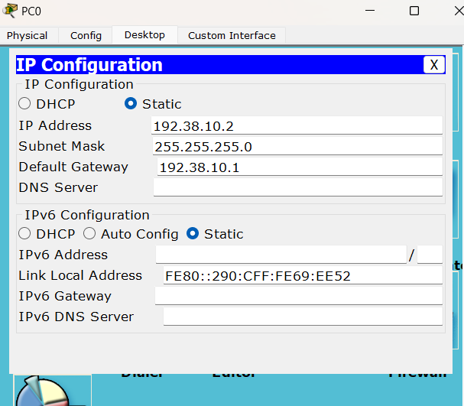
Figure 2-4: IP configuration for PC0

2.3. Configuring Switches
After the VLANs were created on each switch, table 2-2 shows the configurations for the switch’s ports weather they’re access ports or trunks.
Table 2-3: Switches Ports
Switch | Port | Kind | VLAN
Switch 0 | Fa0/1 | Trunk | ---
 | Fa1/1 | Trunk | ---
 | Fa2/1 | Access | VLAN 10
 | Fa3/1 | Access | VLAN 20
Switch 1 | Fa0/1 | Trunk | ---
 | Fa1/1 | Trunk | ---
 | Fa2/1 | Access | VLAN 30
 | Fa3/1 | Access | VLAN 10
Switch 2 | Fa0/1 | Trunk | ---
 | Fa1/1 | Trunk | ---
 | Fa2/1 | Access | VLAN 40
 | Fa3/1 | Access | VLAN 50
 | Fa6/1 | Access | VLAN 20

2.3.1. Configuring Switches Access

In order to configure a switch interface to be an access port to a VLAN the following command is used.

Switch(config -if)# switchport access VLAN <VLAN-NUMBER>

For example, configuring the interface Fa3/1 on switch 0 for VLAN 20.

Switch(config)# interface Fa3/1

Switch(config -if)# switchport access VLAN 20

These configurations should be done for all the access interfaces for all the switches as in table 2-3.

2.3.2. Configuring Switches Trunk
To configure a switch interface to be a trunk the following command is used.
Switch(config -if)# switchport mode trunk
For example, configuring switch 0 with a trunk on interface fa0/1.
Switch(config)# interface Fa0/1
Switch(config -if)# switchport mode trunk
The trunk configurations should be done for all switches interfaces that connects them to routers or other switches as in table 2-2.

2.4. Adding the Third Layer switch to The Topology
As shown previously in figure 2-2, a different switch is added to the topology, that switch is the third layer switch with 4 PCs.
- For the third layer switch, 3560 24PS is used
- For the PCs, PC-PT is used
- For the wires, the automatically choose connection type wire is used.
The switch will be connected to both router0 and switch 0 on the topology in the packet tracer, where extra notes will be placed in order to show the new added networks and the VLAN for each host, another port will be needed for switch 0 so the write command is used to save the previous configurations, then it will be turned off in order to add an extra port.
The IP addresses for the newly added networks with their hosts are in table 2-4 below.
Table 2-4: SVI Networks IPs
Area | Network | Device | Interface | IP Address | Subnet Mask | Wildcard Mask | VLAN ID
Area 0 | 192.8.0.4/30 | Router 0 | Fa1/0 | 192.8.0.5 | 255.255.255.252 | 0.0.0.3 | VLAN 1
 |  | MLS 0 | Fa0/1 | 192.8.0.6 | 255.255.255.252 | 0.0.0.3 | VLAN 1
 | 192.8.10.0/24 | PC 10 | Fa0 | 192.8.10.4 | 255.255.255.0 | 0.0.0.255 | VLAN 10
 | 192.8.50.0/24 | PC 9 | Fa0 | 192.8.50.3 | 255.255.255.0 | 0.0.0.255 | VLAN 50
 | 192.8.60.0/24 | MLS 0 | VLAN 60 | 192.8.60.1 | 255.255.255.0 | 0.0.0.255 | VLAN 60
 |  | PC 8 | Fa0 | 192.8.60.2 | 255.255.255.0 | 0.0.0.255 | VLAN 60
 | 192.8.70.0/24 | MLS 0 | VLAN 70 | 192.8.70.1 | 255.255.255.0 | 0.0.0.255 | VLAN 70
 |  | PC 7 | Fa0 | 192.8.70.2 | 255.255.255.0 | 0.0.0.255 | VLAN  70s

2.5. Multilayer Switch Configurations

2.5.1. Multilayer Switch to Router Configurations
First the network 192.38.0.4/30 should be added to router 0
Router(config)# interface Fa1/0 Router(config-if)# ip address 192.38.0.5 255.255.255.252
Router(config-if)# no shutdown
And for the switch port first in needs to be changed to a router on the networks interface using the following commands.
Switch(config)# interface <TYPE> <SLOT>/<PORT>
Switch(config-if)#no switchport
Then the IP address should be added
Switch(config-if)# ip address <IP-ADDRESS> <SUBNET-MASK>
So, in order to add the switch to the network.
Switch(config)# interface Fa0/1
Switch(config-if)#no switchport Switch(config-if)# ip address 192.38.0.6 255.255.255.252
Switch(config-if)#no shutdown

2.5.2. Configuring VLAN Interfaces IPs
In order to make the multilayer switch act as a default gateway for VLANs the following command is used.
Switch(config)# interface VLAN <VLAN-NUMBER>
Then it will be given an IP address as usual.
Switch(config-if)# ip address <IP-ADDRESS> <SUBNET-MASK>
For example, configuring VLAN 60 with the IP address 192.38.60.1
Switch(config)#interface vlan 60
Switch(config-if)# ip address 192.38.60.1 255.255.255.0
Switch(config-if)#no shutdown

2.5.3. Enabling Routing and Configuring OSPF

For the multilayer switch routing is disabled by default, so in order to enable it the following command is used.

Switch(config)# ip routing

And the OSPF should be configured for the switch to add its networks. For example, configuring OSPF for the switch adding network 192.38.60.0/24.

Switch(config)# router ospf 1

Switch(config-router)#network 192.38.60.0 0.0.0.255 area 0
Plus, router 0 should add the network 192.38.0.4/24 to the OSPF.

2.5.4. Configuring VLANs
All VLANs (10, 20, 30, 40, 50, 60, 70) should be configured on the multilayer switch, and all the three previous switches.
Switch(config)# VLAN 60 Switch(config)# exit
Switch(config)# VLAN 70
Switch(config)# exit

2.5.5. Configuring Access Ports
Configuring an access port on a multi-layer switch is the same as configuring it on a normal switch for example, configuring the fast Ethernet Fa0/2 with VLAN 70.
Switch(config)# interface Fa0/2
Switch(config -if)# switchport access VLAN 70
Switch(config)# interface Fa0/3
Switch(config -if)# switchport access VLAN 60

2.5.6. Configuring Trunk
Configuring an access port on a multiIn order to configure a trunk on a multi-layer switch port the following commands are used.
Switch(config)#interface <TYPE> <SLOT>/<PORT>
Switch(config-if)#switchport trunk encapsulation dot1q
Switch(config-if)#switchport mode trunk
For example, configuring the switch’s interface Fa7/1 that connects it to switch 0 into trunk mode.
Switch(config)#interface Fa7/1
Switch(config-if)#switchport trunk encapsulation dot1q
Switch(config-if)#switchport mode trunk

2.5. Multilayer Switch Configurations

The PC’s that are connected to the multi-layer switch are configured the same way the past PCs are configured, figure 2-5 shows the configurations for PC 8 which should be connected on VLAN 60.

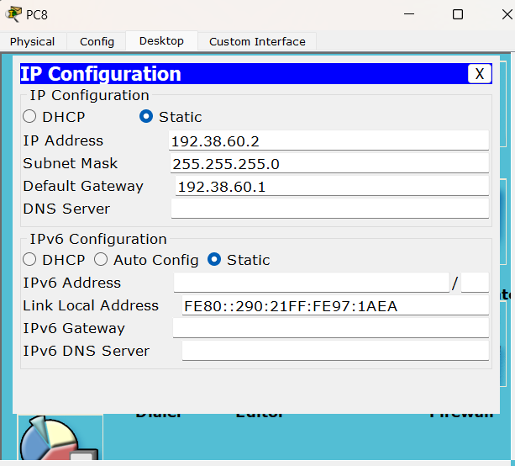
Figure 2-5: IP configuration for a multi-layer switch PC

3. Results

3.1. Results for the Router on Stick Part
To ensure that the topology has been connected and everything is configured successfully, PC1 will attempt to ping PC4 from VLAN 20 to VLAN 40, with the results shown in Figure 3-1.
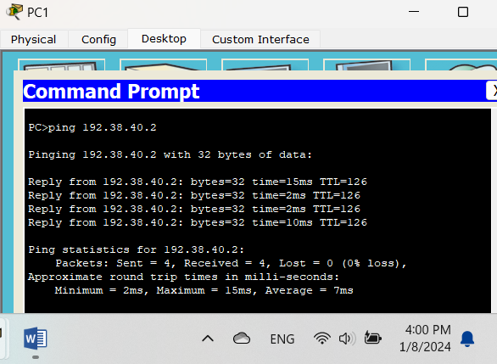
Figure 3-1: Pinging PCs using the command prompt
The interface letter icon ping is also used to ping some devices in the topology, and its results are shown in figure 3-1-1.

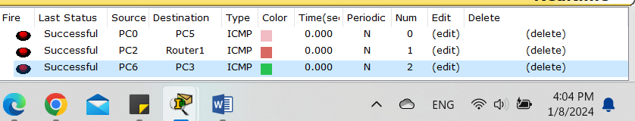
Figure 3-1-1: Pinging results

A ping test from PC1 in VLAN 20 to PC4 in VLAN 40 was successful, with no packet loss, showing excellent VLAN traffic control. This effective communication is confirmed by the network topology. Overall, the network performs successfully.

3.2. Results for The Switch Virtual Interface Part
To check that the topology is successful, the devices will attempt to ping each other. The example below (figure 3-2) shows PC 7 on VLAN 70 attempting to ping PC 9 on VLAN 50.
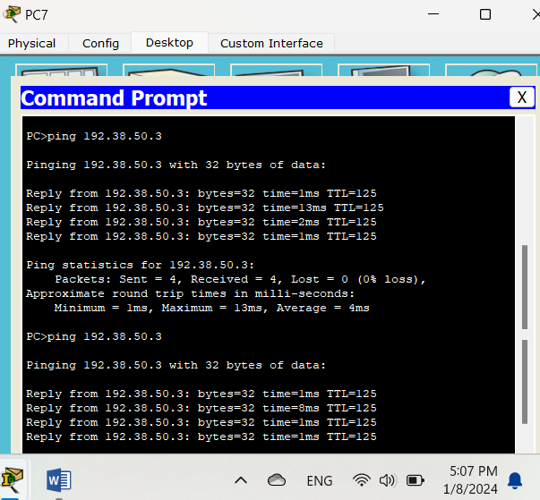
Figure 3-2: Pinging PCs that are connected to the multi-layer switch

The interface ping (with the message icon) is also used to check that the topology works without any mistakes, as the results are shown in figure 3-2-1.
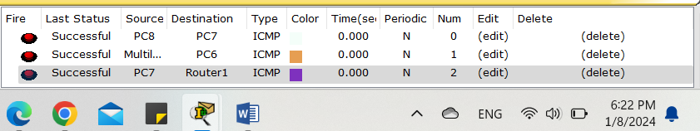
Figure 3-2: Pinging results after connecting the multi-layer switch
There is evidence of a successful network configuration. PC7 on one VLAN pings PC9 on another, and the responses are successful. It means the network is performing a task, seamlessly connecting multiple VLANs. The figure backs this up by showing exactly where the data is going. Everything appears to be properly connected and operating smoothly.

4. To Do

4.1. Building the topology
In networks IP address X symbol was replaced with the least significant two digits of my ID: 1201738. for example, the IP address for the network between Router 0 and Router 1 represent as the following: 192.X.0.0/24 ➔ 192.38.0.0/24

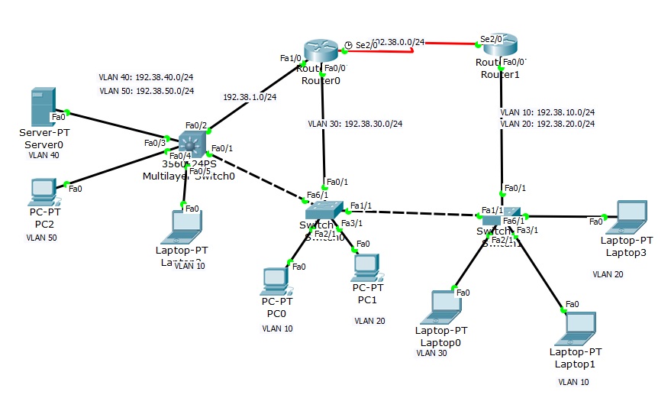
Figure 4-1: ToDO Topology

In this topology, two routers, two normal switches, and one multi-layer switch 3560-24PS with several PCs and one server were connected together on different networks as shown in the figure below. This will require configuring routing protocols between the routers. EIGRP was used for the routers and the multi-switch as a routing protocol.

4.2 IPs configuration:
- The figure 4-1-1 below shows the IP addresses and Subnet masks for PC2 .
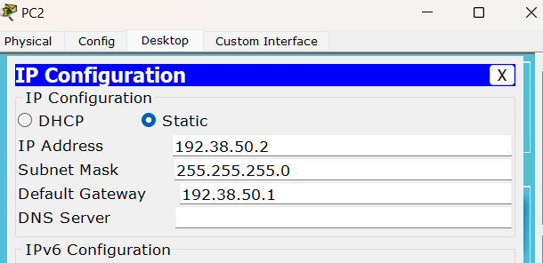
Figure 4-1-1: IP addresses for PC
- The figure 4-1-2 below shows the IP addresses and Subnet masks for Laptop0.
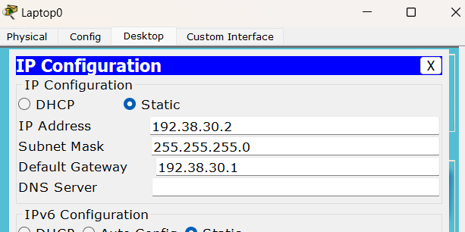
Figure 4-1-2: IP addresses for Laptop
- The figure 4-1-2 below shows the IP addresses and Subnet masks for Server0.
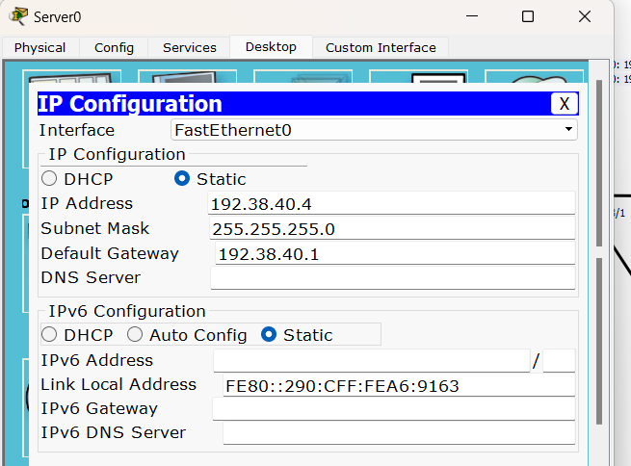
Figure 4-1-3: IP addresses for Server
- IP address for Router 0:

The following commands were used to assign the IP address for the sub interface Fa0/0.30
Router(config)# interface Fa0/0.30
Router(config-subif)#encapsulation dot1Q 30
Router(config-subif)#ip address 192.38.30.1 255.255.255.0

- IP address for Router 1:

The following commands were used to assign the IP address for the sub interfaces Fa0/0.10 and Fa0/0.20
Router(config)# interface Fa0/0.10
Router(config-subif)#encapsulation dot1Q 10
Router(config-subif)#ip address 192.38.10.1 255.255.255.0
Router(config)# interface Fa0/0.20
Router(config-subif)#encapsulation dot1Q 20
Router(config-subif)#ip address 192.38.20.1 255.255.255.0

- IP address the multilayer switch:

IP address was added to the switch port connected to the router, so firstly switch port was changed to a router port and then IP address was set, the following commands: Switch(config)#interface fa0/2
Switch(config-if)#no switchport
Switch(config-if)#ip address 192.38.1.2 255.255.255.0
Switch(config)#interface vlan 40
Switch(config-if)# ip address 192.38.40.1 255.255.255.0
Switch(config)#interface vlan 50
Switch(config-if)# ip address 192.38.40.1 255.255.255.0

4.3 Creating VLANs:
The values of all VLANs were assigned to all switches in the topology, the following commands were written for the two normal PT switches and the multilayer switch
Switch(config)# VLAN 10
Switch(config-vlan)# exit
Switch(config)# VLAN 20
Switch(config-vlan)# exit
Switch(config)# VLAN 30
Switch(config-vlan)# exit
Switch(config)# VLAN 40
Switch(config-vlan)# exit
Switch(config)# VLAN 50
Switch(config-vlan)# exit

4.4 Configuring EIGRP Routing:
For router0:
Router(config)#router eigrp 10
Router(config-router)#network 192.38.10.0
Router(config-router)#network 192.38.30.0
Router(config-router)#network 192.38.0.0
Router(config-router)#network 192.38.1.0

For router1:
Router(config)#router eigrp 10
Router(config-router)#network 192.38.10.0
Router(config-router)#network 192.38.20.0
Router(config-router)#network 192.38.0.0

For multi-Switch:
Router(config)#router eigrp 10
Router(config)#network 192.38.1.0
Router(config)#network 192.38.40.0
Router(config)#network 192.38.50.0
Router(config)#network 192.38.10.0

4.5 Results:
All the PCs and Laptops should be able to ping each other as shown in the figure 4-5 below.

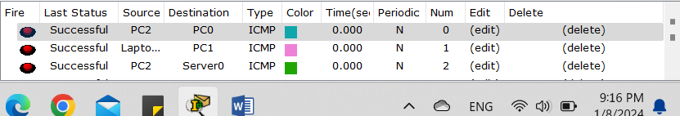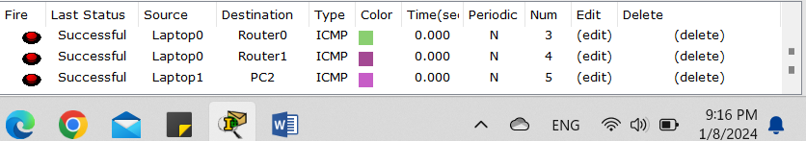
Figure 4-5: ToDo Results

Conclusion
In conclusion, this experiment demonstrated the necessity of virtual networking, as well as the specifications and purposes of switches and multilayered switches, as well as how to set them using command lines.
Virtual local area networks are frequently used because they provide considerably more flexibility, as demonstrated by this experiment, which demonstrated how PC hosts may be located far apart while yet being connected to the same network.
This project also presented several new concepts, such as the sub interface on a router, switch topologies with trunks and access ports, and, lastly, the third layer switch that also functions as a router.
Cisco packet tracer gives all of the necessary information to assist in learning and gaining knowledge about all networking fields, whether they be virtual or physical networking applications.

References

- https://en.wikipedia.org/wiki/Network_switch
[Accesses Time: 3/1/2024 3:20pm]
- https://www.javatpoint.com/switch-vs-router
[Accesses Time: 3/1/2024 3:28pm]
- Lab manual: ENCS4130Manual_2023.
[Accesses Time: 1/1-8/1 2024]
- https://www.techtarget.com/searchnetworking/definition/virtual-LAN
[Accesses Time: 5/1/2024 5:45pm]
- https://www.softwaretestinghelp.com/what-is-a-vlan
[Accesses Time: 5/1/2024 5:57pm]
- https://documentation.meraki.com/MS/Layer_3_Switching/Layer_3_vs_Layer_2_Switching
[Accesses Time: 5/1/2024 6:22pm]



